- MANAGE REGULATORY NOTIFICATION
  - Any notification awaiting a response will be listed under NOTIFICATIONS tab. Click on View for more details for each notification.
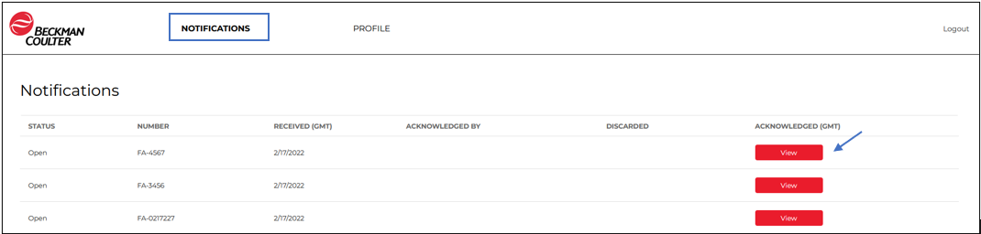

  - From here you can click the link and download the notification letter as well as any other attachments.
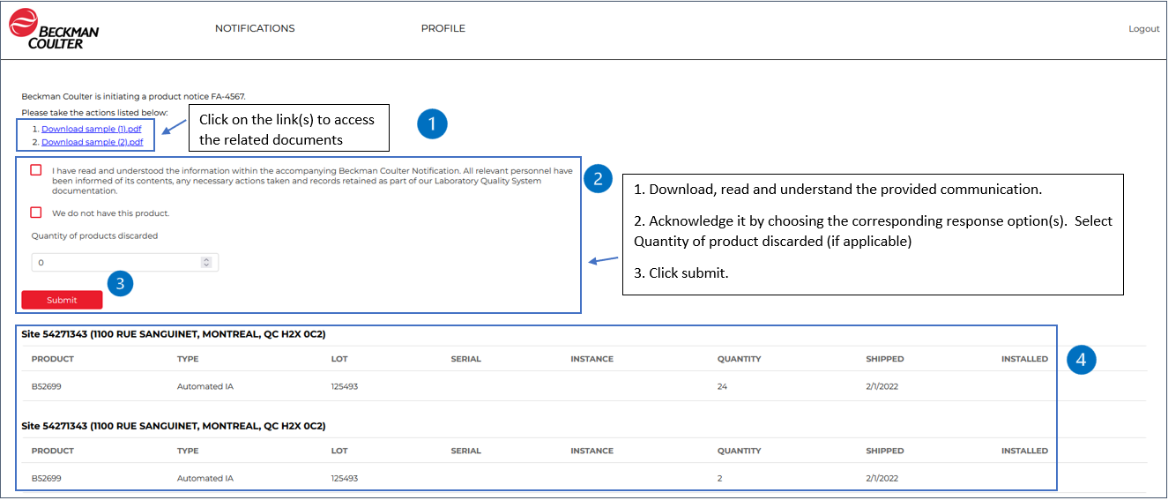

Note: You will find the site for which you are registered to respond to the regulatory notification (section 4 in the image above).

  - After you click submit, you will be taken to the screen that confirms that the regulatory notification has been successfully acknowledged. Click on the exit icon .

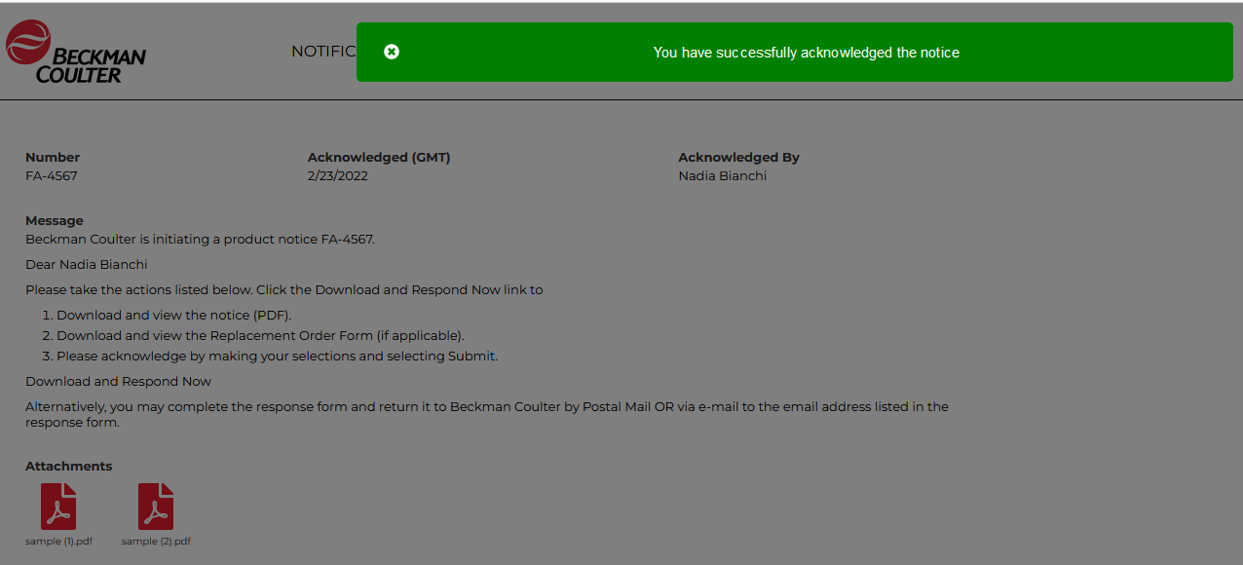

Note: You will also receive an e-mail containing the acknowledgment confirmation:

  - You will then be taken back to the page with the acknowledgment details already displayed. From here, you can go to review other “Notifications” or your regulatory contact “Profile”.
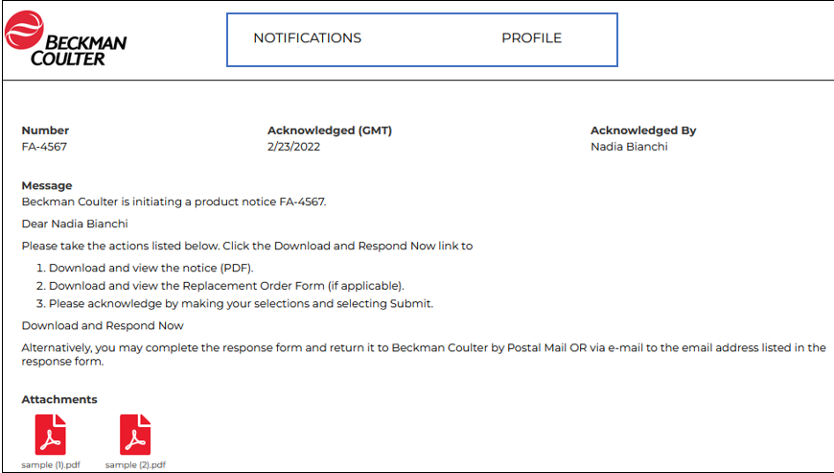
  - If you click “Notifications”, you will then be taken back to Notification list page. As long as there are open notifications (i.e., not acknowledged) you may keep responding for the regulatory notification related to the site you are responsible for. When all are answered for, no further notifications will show the button “View”. You will also view your acknowledged or other acknowledged notifications for your site(s). Hover with the mouse cursor over Regulatory Notifications and click on the one you wish to view.
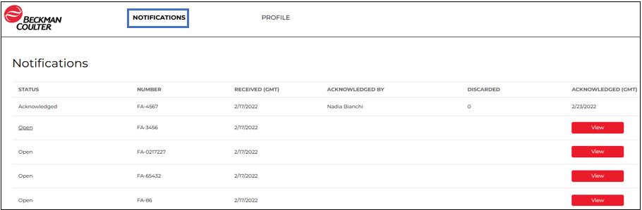

- MANAGE REGULATORY CONTACTS
  - View/Edit Existing Customer’s Regulatory Contact Information
- If you click “Profile” you can also maintain Regulatory Contact information.
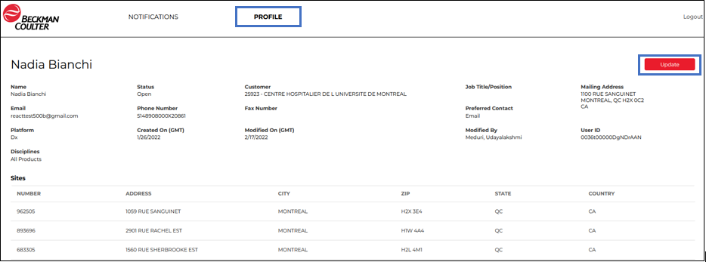

- Under “Profile” you may update your Contact Details, Opt-in Products and Opt-in Sites. Click on the “Disciplines” dropdown list and Add or Remove the products you want to be notified of.

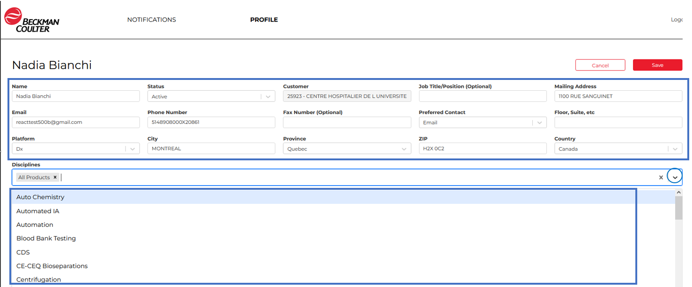

- Under “Profile” you may update your Contact Details, Opt-in Products and Opt-in Sites. Click or Unclick on the “OPT-IN” check box to Add or Remove site locations you want to be notified of.
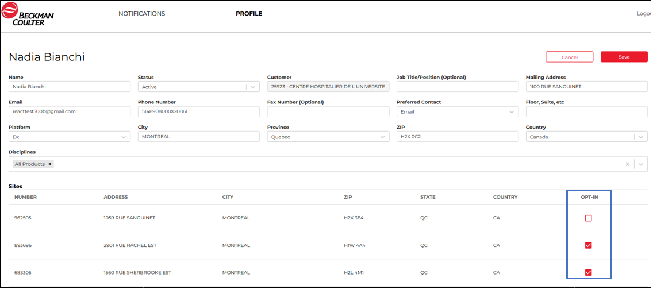

- If you have made changes to the Contact Details, click on Save to keep your changes, or Cancel to revert back to the previously stored information. If you don’t click on Save, you will lose any of the changes made.
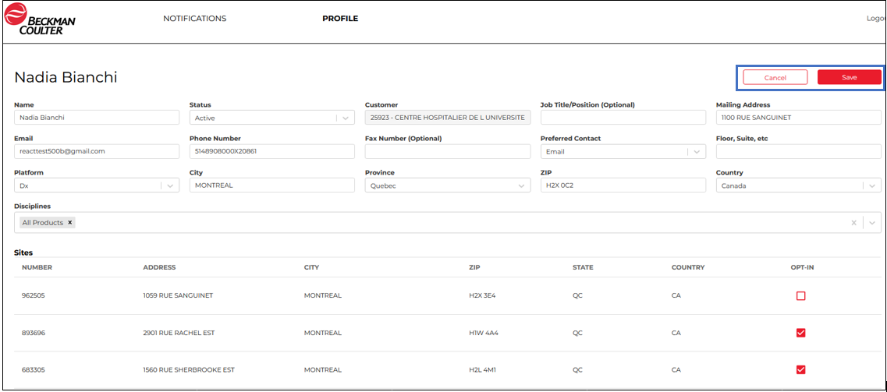
  - Creating New Regulatory Contacts
This section covers the steps for creating new Regulatory Contacts.
Prior to beginning these tasks: You must have the Regulatory Contact Name details and EBS (Oracle E-Business Suite) Customer Number for which the contact will be associated to.
- Select Contacts tab and click “Add Contact” button
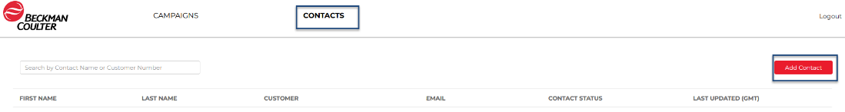
- In the “Customer” field, enter the customer number for which the regulatory contact will be associated to.
- All available fields can be filled if the contact information is available. The following fields are required to be entered; otherwise, an error message will be displayed, or the regulatory notification will not be sent to the newly created contact:
- First and Last Name
- Status – Defaulted to Active
- Preferred Contact method
- Email: If preferred contact is email, enter email information so that emails are sent out.
- Platform
- Disciplines (one or multiple must be selected) – Defaulted to All Disciplines
- Opt-in site(s): If no site is selected; no notification will be sent to the contact. *

*Note: The site(s) can only be selected once the regulatory contact has been saved. Follow steps below (d-g) for adding the applicable sites to the contact profile.

- Once all the information is entered, click Save.
A notification that the contact was successfully created will show up.
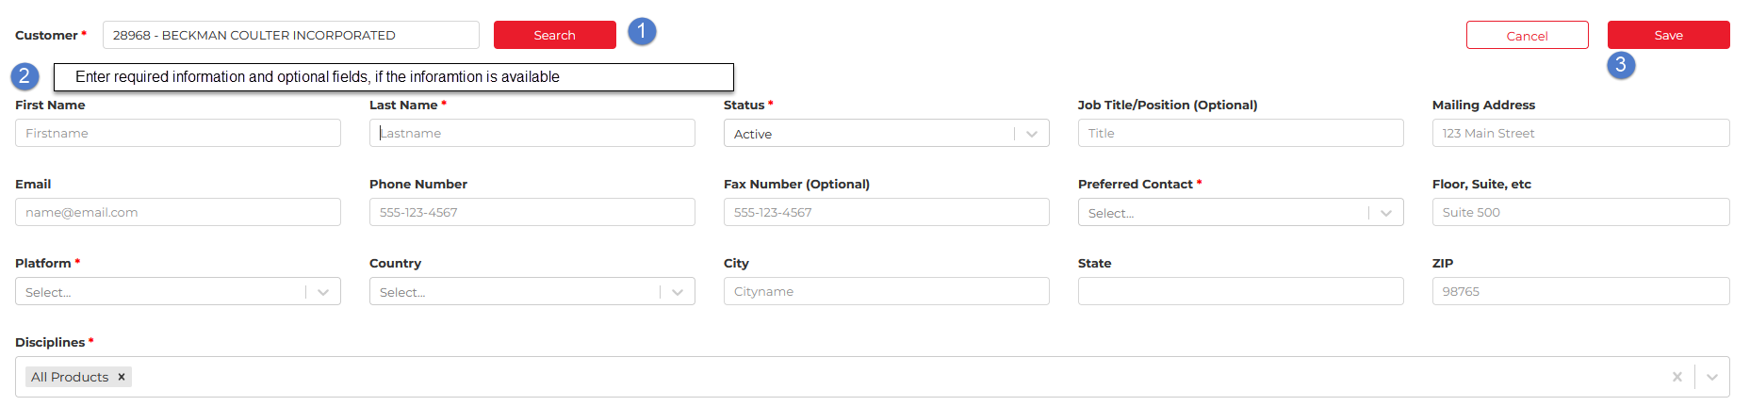
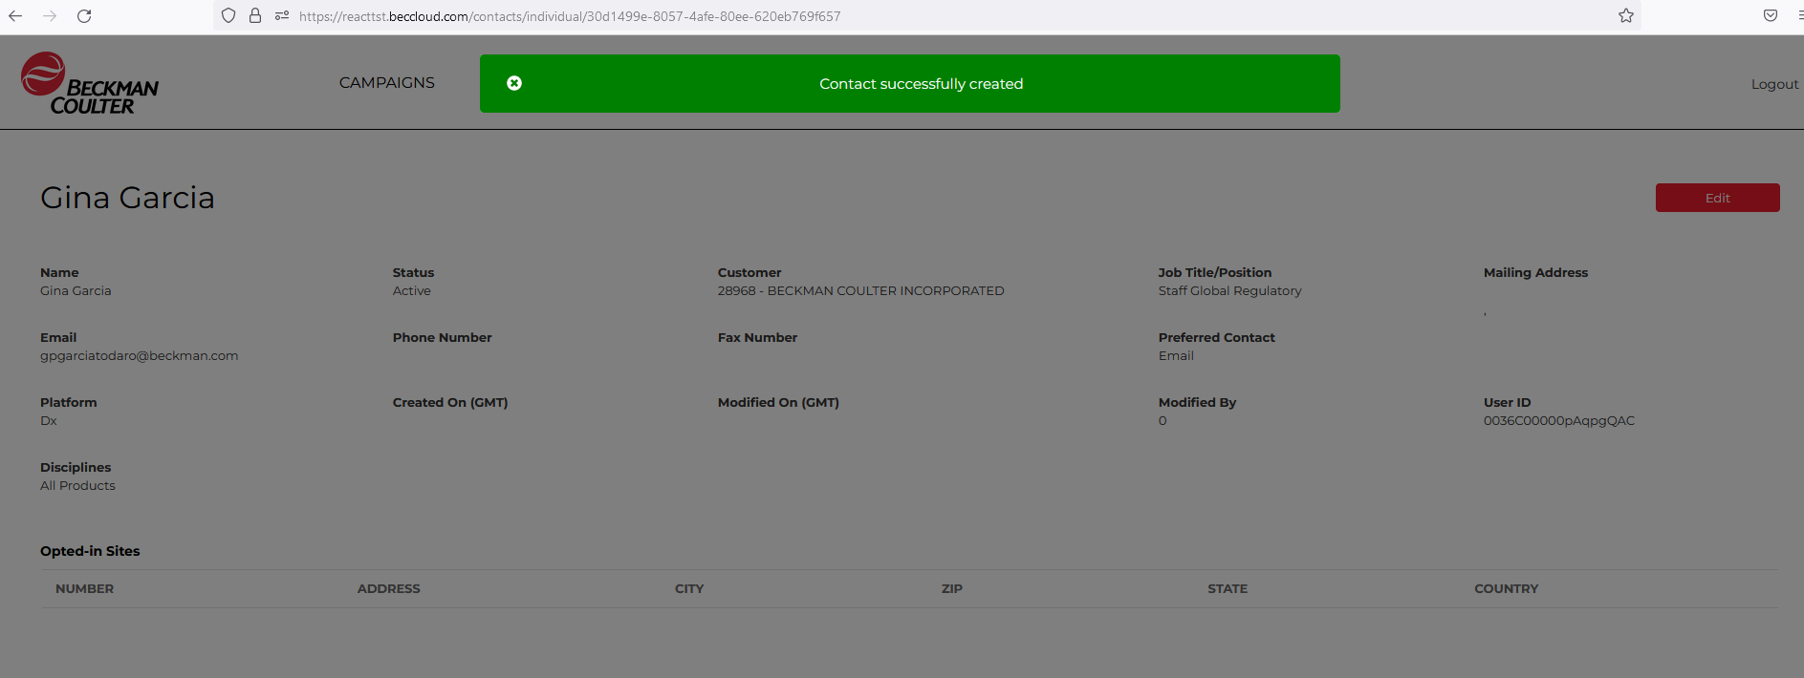

- Once a specific contact is created all related information related to the contact will be displayed, click Edit to select applicable customer sites.
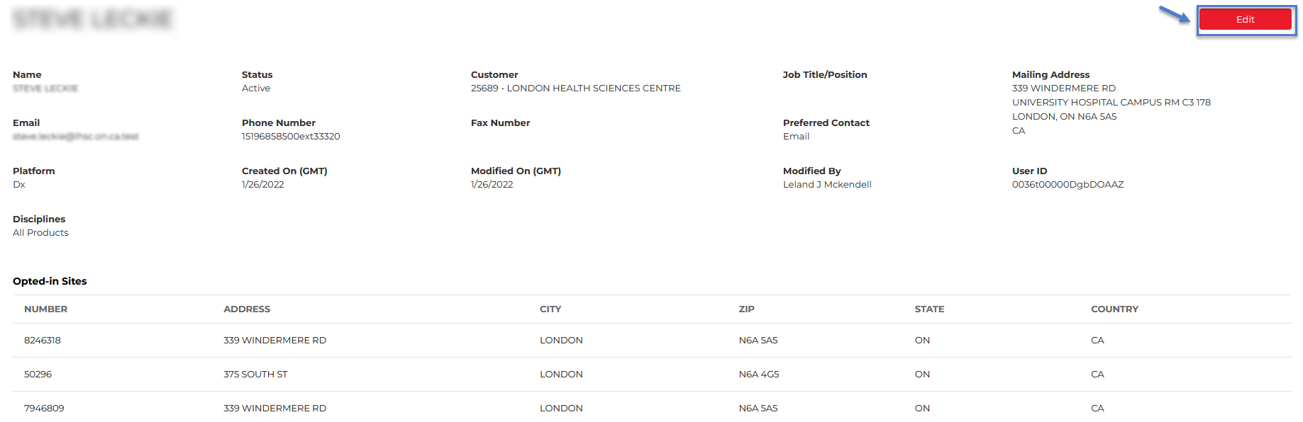

- The list of all the sites associated with the Customer number will be displayed in the sites list. For editing the Site “Opt-In” options
- Check "Opt-In box" if the contact should receive regulatory notification for the specific site.
- Do not check the "Opt-In box" if the contact should NOT receive regulatory notification for the specific site.
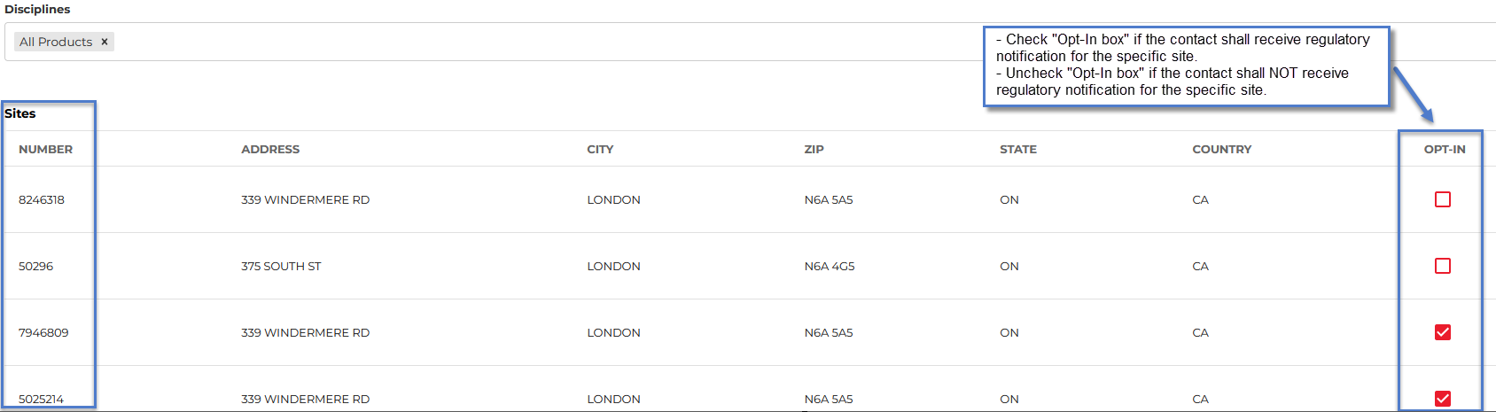
- Once all required changes have been entered, click Save to save the changes.
