MANAGE REGULATORY NOTIFICATION
- Any notification awaiting a response will be listed under My Open Notifications. Click on View for more details for each notification.
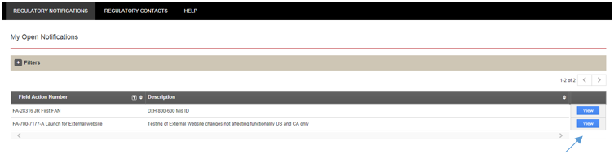

- From here you can open and print the notification letter as well as any other attachments.

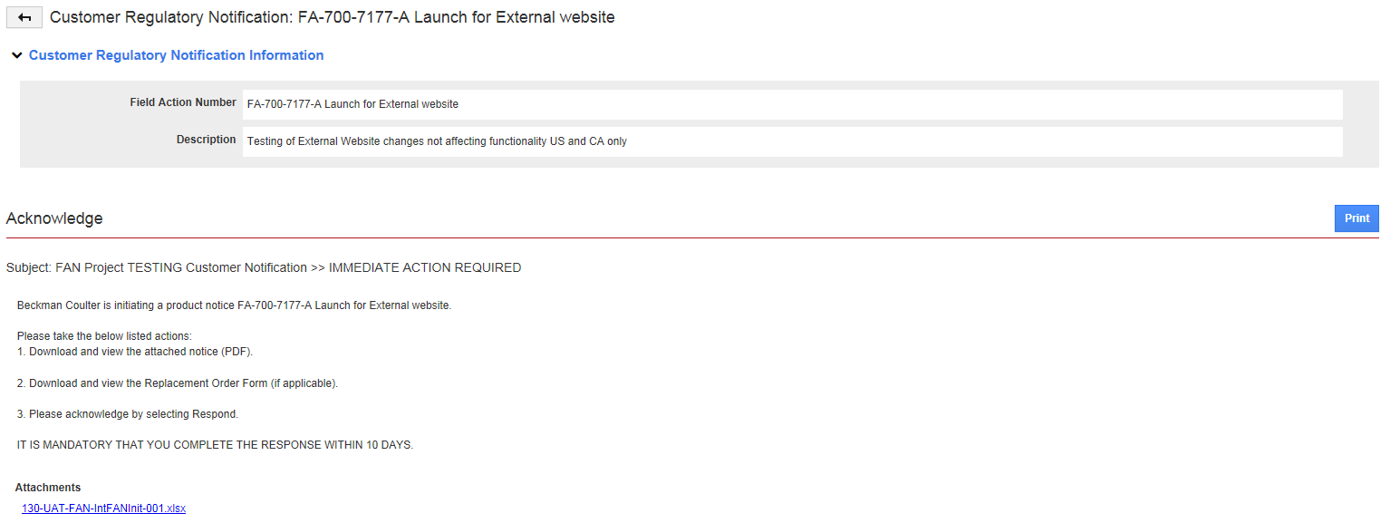

- Select the site(s) you are responding for in the box to the left of Site Number and click on Respond.
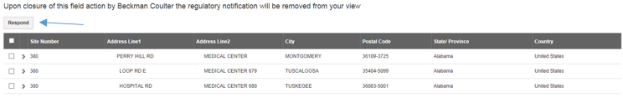

- Select either one or both of the options. Click on Save.
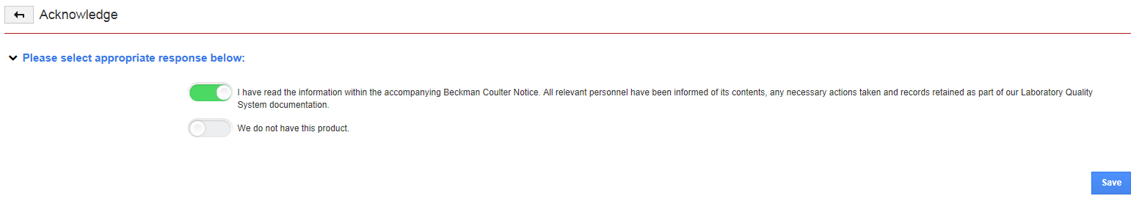
- You will then be taken back to the My Open Notifications page. As long as there are open notifications you may keep responding for the sites you are responsible for. When all are answered for, no further notifications will be listed. You may also view your acknowledged or other acknowledged notifications for your site(s). Hover with the mouse cursor over Regulatory Notifications and click on the one you wish to view.

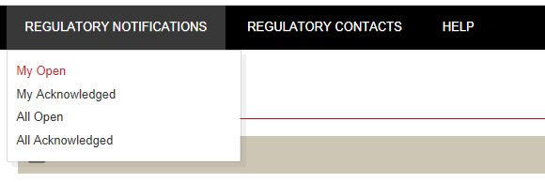

MANAGE REGULATORY CONTACTS
- You can also maintain Regulatory Contact information.
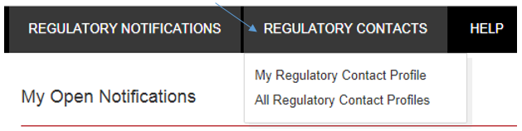

- Under My Regulatory Contact Profile you may update your Contact Details, Opt-in Products and Opt-in Locations. Click on Add to add products and/or locations you want to be notified of; click on the trash can to remove products and/or locations.

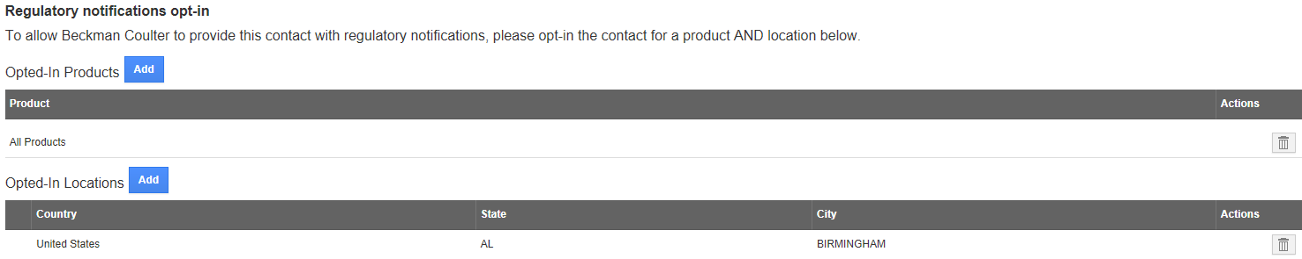

- If you have made changes to the Contact Details, click on Save to keep your changes, or Cancel to revert back to the previously stored information. If you don’t click on Save, you will lose any of the changes made.
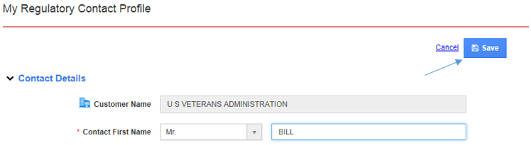

- You can also view All Regulatory Contacts currently registered with your account, as well as update their info and opt-ins, and create new contacts.
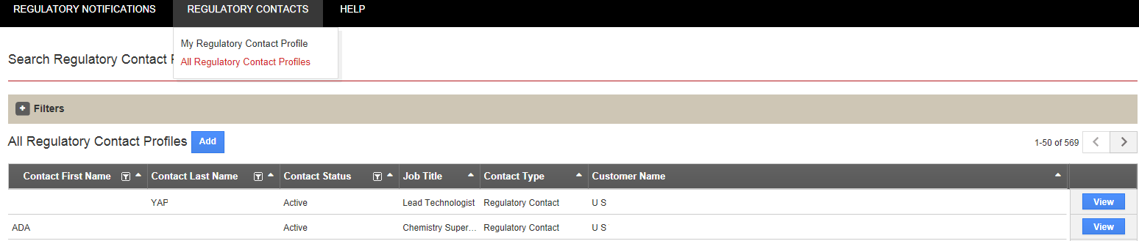

Clicking on the plus (+) sign next Filters allows you to search by Country and State/Province.

- Under Help you will find this Tutorial as well as information on how to contact us.
